Documenting IAM Set UP and User Allocation between Groups

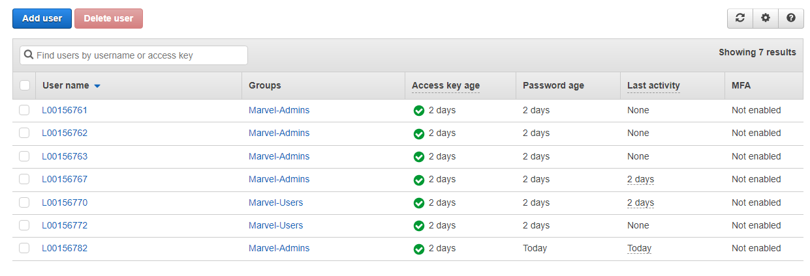

Hello,

You now have access to the AWS Management Console for the account ending in 1129. ------

Sign-in URL: <https://501764301129.signin.aws.amazon.com/console>

Your password will be provided separately by your AWS account administrator. During your first sign-in, you must change your password.

------

Stay connected with AWS by creating a profile: <https://pages.awscloud.com/IAM-communication-preferences.html>

Sincerely,   
Your AWS Account Administrator

Documenting Root User Set Up

